Citykart

A Skill Oriented Course Web Application report

Submitted in the partial fulfillment of the requirements for

the award of the degree of

Bachelor of Technology

in

Computer Science and Engineering

by

P.Vamsi 20761A05B4

Under the guidance of

Dr. K Devi Priya
Associate Professor, Dept. of CSE


Department of Computer Science and Engineering
Lakireddy Bali Reddy College of Engineering (Autonomous)
Accredited by NAAC & NBA (Under Tier - I)
Affiliated to JNTUK, Kakinada; ISO 9001:2015 Certified
2021-22

Certificate

This is to certify that the Skill Oriented Course Web Application / Project entitled “Citykart” is being submitted by P.vamsi in partial fulfillment for the award of B. Techin Computer Science & Engineering to the Jawaharlal Nehru Technological University Kakinada is a record of bonafide work carried out by him/her under our guidance.

The results embodied in this Skill Oriented Course Web Application / Project report have not been submitted to any other University or Institute for the award of any degree or diploma.

Projectguide Head of the department
Dr. K Devi Priya Dr.D.Veeraiah
Associate Professor Professor

External Examiner
ACKNOWLEDGEMENT

I would like to thank Dr. K Devi Priya, Associate Professor, CSE department for the encouraging and support in carrying out this Skill Oriented Course Web Application.

I also take the privilege to record my thanks to Dr. D. Veeraiah, Professor,Head of the Department of CSE whose encouragement, cooperation and valuable support crown my success.

I express my thanks to the support given by management in completing my Web Application / Project. I also express my sincere gratitude & deep sense of respect to the Principal, Dr.K. Appa Rao for making us available all the required assistance and his support and inspiration to carry out this Skill Oriented Course Web Application / Project in the Institute.

I am thankful to the teaching and non-teaching staff of CSE department for their direct as well as indirect help in my Skill Oriented Course Web Application / Project.

I am elated to avail my selves to this opportunity to express my deep sense of gratitude to my parents.

Skill Oriented Course Web Application / Project Title

Abstract

Welcome to Citykart, your number one source for all things Mobiles, electronics devices food etc..,. We're dedicated to giving you the very best of products, with a focus on three characteristics, ie: dependability, customer service and uniqueness.Founded in 2020 by vamsi, Citykart has come a long way from
its beginnings in a home office, toolshed, Houston, TX. When he first started out, his passion for helping other parents be more eco-friendly, providing the best equipment for his fellow coustomers drove him to do intense research, quit her day job, and gave him the impetus to turn hard work and inspiration into to a booming online store. We now serve customers all over the US, the world, the Austin and are thrilled to be a part of the quirky, eco-friendly, fair trade wing of the fashion, baked goods, watches industry.

We hope you enjoy our products as much as we enjoy offering them to you. If you have any questions or comments, please don't hesitate to contact us.

CONTENTS
CONCEPTS Page No
1. Introduction 1
2. Modules/Technogies Used
2.1 HTML 6
2.2 CSS 9
2.3 Javascript 12
3. Coding 15
5.Results/Screens 24
6. Conclusion 27
7. References 27

INTRODUCTION:
Online shopping is a form of electronic commerce which allows consumers to directly buy goods or services from a seller over the Internet using a web browser or a mobile app. Consumers find a product of interest by visiting the website of the retailer directly or by searching among alternative vendors using a shopping search engine, which displays the same product's availability and pricing at different e-retailers.

The marketing around the digital environment, customer's buying behaviour may not be influenced and controlled by the brand and firm, when they make a buying decision that might concern the interactions with search engine, recommendations, online reviews and other information. With the quickly separate of the digital devices environment, people are more likely to use their mobile phones, computers, tablets and other digital devices to gather information. In other words, the digital environment has a growing effect on consumer's mind and buying behaviour. In an online shopping environment, interactive decision may have an influence on aid customer decision making. Each customer is becoming more interactive, and though online reviews customers can influence other potential buyers' behaviors. In addition, not only those reviews, people more rely on other people's post information about product commends on social media. There will shows common problems in the past and some solutions or comments of the merchants will be attached for customer reference.

My website Citykart is an e-commerce website.It provides a wide range of products to buy.
Provided with navigation bar user can easily navigate through different categories.Due to user-friendly design of website one can easily access the website and the shop their required items.
There is a registration page available to create an account and login page to login.To buy any product when customer clicks on buy now will be redirected to payment page.We provide various payment options to ensure user comfort.

It contains of different categories like Electronics,Fashion,Sports,… with offers that attract customers and they could afford.We ensure quality of products and responsible delivery without any damage to the products.
2.MODULES/TECHNOLOGIES USED:
2.1 HTML
2.2 CSS
2.3 JAVASCRIPT

HTML
HTML stands for Hyper Text Markup Language.
HTML is the standard markup language for creating Web pages.
HTML describes the structure of a Web page.
HTML consists of a series of elements.
HTML elements tell the browser how to display the content.

HTML Headings:

HTML headings are defined with the <h1> to <h6> tags.
<h1> defines the most important heading.
<h6> defines the least important heading.
EXAMPLE:
<h1>heading</h1>

HTML Paragraphs:

HTML paragraphs are defined with the <p> tag.
EXAMPLE:
<p>paragraph</p>

HTML Links:

HTML links are defined with the <a> tag:
EXAMPLE:
<a href="https://www.w3schools.com">This is a link</a>

HTML Images:

HTML images are defined with the <img> tag.
The source file (src), alternative text (alt), width, and height are provided as attributes:
EXAMPLE:
<img src="w3schools.jpg" alt="W3Schools.com" width="104" height="142">

HTML Styles:

The HTML style attribute is used to add styles to an element, such as color, font, size, and more.
Setting the style of an HTML element, can be done with the style attribute.
<tagname style="property:value;">
Background Color:The CSS background-color property defines the background color for an HTML element.
EXAMPLE:
<h1 style="background-color:powderblue;">This is a heading</h1>
<p style="background-color:tomato;">This is a paragraph.</p>

HTML Formatting Elements:
Formatting elements were designed to display special types of text:

<b> - Bold text
<strong> - Important text
<i> - Italic text
<em> - Emphasized text
<mark> - Marked text
<small> - Smaller text
<del> - Deleted text
<ins> - Inserted text
<sub> - Subscript text
<sup> - Superscript text

HTML Forms:

An HTML form is used to collect user input. The user input is most often sent to a server for processing.
The <form> element is a container for different types of input elements, such as: text fields, checkboxes, radio buttons, submit buttons, etc.
An <input> element can be displayed in many ways, depending on the type attribute.

Here are some examples:

Type | Description
<input type="text"> | Displays a single-line text input field
<input type="radio"> | Displays a radio button (for selecting one of many choices)
<input type="checkbox"> | Displays a checkbox (for selecting zero or more of many choices)
<input type="submit"> | Displays a submit button (for submitting the form)
<input type="button"> | Displays a clickable button

EXAMPLE:
<form>
<label for="fname">First name:</label><br>
<input type="text" id="fname" name="fname"><br>
<input type="radio" id="html" name="fav_language" value="HTML">
<label for="html">HTML</label><br> <input type="checkbox" id="vehicle1" name="vehicle1" value="Bike">
<label for="vehicle1"> I have a bike</label><br>
<input type="submit" value="Submit">
</form>

HTML TABLES:

HTML tables allow web developers to arrange data into rows and columns.
Each table cell is defined by a <td> and a </td> tag.
Each table row starts with a <tr> and end with a </tr> tag.
Sometimes you want your cells to be headers, in those cases use the <th> tag instead of the <td> tag:

EXAMPLE:

<table>
<tr>
<th>Person 1</th>
<th>Person 2</th>
<th>Person 3</th>
</tr>
<tr>
<td>Emil</td>
<td>Tobias</td>
<td>Linus</td>
</tr>
<tr>
<td>16</td>
<td>14</td>
<td>10</td>
</tr>
</table>

HTML Lists:

HTML lists allow web developers to group a set of related items in lists.

Unordered HTML List:
An unordered list starts with the <ul> tag. Each list item starts with the <li> tag.
The list items will be marked with bullets (small black circles) by default:

Example:
<ul>
<li>Coffee</li>
<li>Tea</li>
<li>Milk</li>
</ul>

Ordered HTML List:
An ordered list starts with the <ol> tag. Each list item starts with the <li> tag.
The list items will be marked with numbers by default:

EXAMPLE:
<ol>
<li>Coffee</li>
<li>Tea</li>
<li>Milk</li>
</ol>

CSS

CSS stands for Cascading Style Sheets.
CSS describes how HTML elements are to be displayed on screen, paper, or in other media.
CSS saves a lot of work. It can control the layout of multiple web pages all at once.
External stylesheets are stored in CSS files.

Three Ways to Insert CSS:

1.External CSS
2.Internal CSS
3.Inline CSS

EXTERNAL CSS:
Each HTML page must include a reference to the external style sheet file inside the <link> element, inside the head section.

EXAMPLE:
<head>
<link rel="stylesheet" href="mystyle.css">
</head>
INTERNAL CSS:
An internal style sheet may be used if one single HTML page has a unique style.
The internal style is defined inside the <style> element, inside the head section.

EXAMPLE:
<style>
body {
background-color: linen;
}
h1 {
color: maroon;
margin-left: 40px;
}
</style>

Inline CSS:
An inline style may be used to apply a unique style for a single element.
To use inline styles, add the style attribute to the relevant element. The style attribute can contain any CSS property.

EXAMPLE:
<h1 style="color:blue;text-align:center;">This is a heading</h1>
<p style="color:red;">This is a paragraph.</p>

CSS BACKGROUNDS:

The CSS background properties are used to add background effects for elements.
In these chapters, you will learn about the following CSS background properties:
1.background-color
2.background-image
3.background-repeat
4.background-attachment
5.background-position

EXAMPLE:

div {
background-color: green;
opacity: 0.3;
}

body {
background-image: url("paper.gif");
background-repeat: no-repeat;
background-position: right top;
background-attachment: scroll;
}

The background-attachment property specifies whether the background image should scroll or be fixed.

CSS PADDING:

The CSS padding properties are used to generate space around an element's content, inside of any defined borders.

CSS has properties for specifying the padding for each side of an element:

- padding-top
- padding-right
- padding-bottom
- padding-left

All the padding properties can have the following values:

- length - specifies a padding in px, pt, cm, etc.
- % - specifies a padding in % of the width of the containing element.
- inherit - specifies that the padding should be inherited from the parent element.

EXAMPLE:

div {
padding-top: 50px;
padding-right: 30px;
padding-bottom: 50px;
padding-left: 80px;
}

(or)

div {
padding: 25px 50px 75px 100px;
}

The position Property:

The position property specifies the type of positioning method used for an element.
There are five different position values:

- static
- relative
- fixed
- absolute
- sticky

An element with position: static; is not positioned in any special way; it is always positioned according to the normal flow of the page.

An element with position: relative; is positioned relative to its normal position.

An element with position: fixed; is positioned relative to the viewport, which means it always stays in the same place even if the page is scrolled. The top, right, bottom, and left properties are used to position the element.

An element with position: absolute; is positioned relative to the nearest positioned ancestor (instead of positioned relative to the viewport, like fixed).
However; if an absolute positioned element has no positioned ancestors, it uses the document body, and moves along with page scrolling.

An element with position: sticky; is positioned based on the user's scroll position.
A sticky element toggles between relative and fixed, depending on the scroll position. It is positioned relative until a given offset position is met in the viewport - then it "sticks" in place (like position:fixed).

EXAMPLE:

div.relative {
position: relative;
width: 400px;
height: 200px;
border: 3px solid #73AD21;
}

JAVASCRIPT

JavaScript is the world's most popular programming language.
JavaScript is the programming language of the Web.
JavaScript is easy to learn.

JavaScript Can Change HTML Content:

One of many JavaScript HTML methods is getElementById().
The example below "finds" an HTML element (with id="demo"), and changes the element content (innerHTML) to "Hello JavaScript":

EXAMPLE:
document.getElementById("demo").innerHTML = "Hello JavaScript";

Javascript Operators:

EXAMPLE:
<html>
<body>
<h2>JavaScript Arithmetic</h2>
<h3>The * Operator</h3>
<p id="demo"></p>
<script>
let x = 5;
let y = 2;
let z = x * y;
document.getElementById("demo").innerHTML = z;
</script>
</body>
</html>

JAVASCRIPT FUNCTIONS:

A JavaScript function is a block of code designed to perform a particular task.
A JavaScript function is executed when "something" invokes it (calls it).

EXAMPLE:

<!DOCTYPE html>
<html>
<body>
<h2>JavaScript Functions</h2>
<p>This example calls a function which performs a calculation, and returns the result:</p>
<p id="demo"></p>
<script>
function myFunction(p1, p2) {
return p1 * p2;
}
document.getElementById("demo").innerHTML = myFunction(4, 3);
</script>
</body>
</html>

HTML Events:

An HTML event can be something the browser does, or something a user does.
Here are some examples of HTML events:

- An HTML web page has finished loading
- An HTML input field was changed
- An HTML button was clicked

Common HTML Events:
Here is a list of some common HTML events:
Event | Description
onchange | An HTML element has been changed
onclick | The user clicks an HTML element
onmouseover | The user moves the mouse over an HTML element
onmouseout | The user moves the mouse away from an HTML element
onkeydown | The user pushes a keyboard key
onload | The browser has finished loading the page

EXAMPLE:

<!DOCTYPE html>
<html>
<body>
<h2>JavaScript HTML Events</h2>
<p>Click the button to display the date.</p>
<button onclick="displayDate()">The time is?</button>
<script>
function displayDate() {
document.getElementById("demo").innerHTML = Date();
}
</script>
<p id="demo"></p>
</body>
</html>
CODING:

HOME PAGE:

<html>
<head>
<title>CityCart</title>
<link rel="stylesheet" type="text/css" href="bootstrap.css">
<link rel="stylesheet" type="text/css" href="project6.css">
</head>

<body>
<table border="0" width="100%" bgcolor="#2874F0">
<tr>
<td><img src="cards\logo.png" align="right" height="50"></td>
<td><input type="text" size="50" placeholder="Search for products,brands and more"></td>
<th><font color="white">Home</font></th>
<th><font color="white">Login & Signup</font></th>
<th><font color="white">Cart</font></th>
</tr>
</table>
<table border="0" width="100%" bgcolor="white" height="8%">
<tr>
<th width="12.5%"><a href="electronics.html">Electronics</a></th>
<th width="12.5%"><a href="#">TV & Appliances</a></th>
<th width="12.5%"><a href="mobiles.html">Mobiles</a></th>
<th width="12.5%"><a href="food6.html">Food</a></th>
<th width="12.5%"><a href="#">Earphones</a></th>
<th width="12.5%"><a href="#">Home & Furniture</a></th>
<th width="12.5%"><a href="#">Books & magazines</a></th>
<th width="12.5%"><a href="#">Offer Zone</a></th>
</tr>
</table>

<img src="banner4.jpg" width="100%" height="46%">
<br><br>

<h2><a href="#">Ear Phones</a></h2>
<div class="row container-fluid ">
<div id="s" class="img-thumbnail col-sm-3">
<img src="Ear phones\EP1.jpg" width="300" height="250">
<div class="caption"><p>boat 250<ul><li>MRP-599/-</li></ul><a href="delievery.html"><button>BUY NOW</button>&nbsp;&nbsp;&nbsp;<button>ADD TO CART</button></a></p>
</div>
</div>
<div id="s" class="img-thumbnail col-sm-3">
<img src="Ear phones\EP2.jpg" width="300" height="250">
<div class="caption"><p>MINISO Colorful Music Earphone<ul><li>MRP-200/-</li></ul><a href="delievery.html"><button>BUY NOW</button>&nbsp;&nbsp;&nbsp;<button>ADD TO CART</button></a></p>
</div>
</div>
<div id="s" class="img-thumbnail col-sm-3">
<img src="Ear phones\EP3.jpg" width="300" height="250">
<div class="caption"><p>Mi Black wired earphone<ul><li>MRP-799/-</li></ul><a href="delievery.html"><button>BUY NOW</button>&nbsp;&nbsp;&nbsp;<button>ADD TO CART</button></a></p>
</div>
</div>
<div id="s" class="img-thumbnail col-sm-3">
<img src="Ear phones\EP4.jpg" width="300" height="250">
<div class="caption"><p>Bose Quiet Confort Earphone<ul><li>MRP-1200/-</li></ul><a href="delievery.html"><button>BUY NOW</button>&nbsp;&nbsp;&nbsp;<button>ADD TO CART</button></a></p>
</div>
</div>
</div>
<br>

<h2><a href="#">Pendrives</a></h2>
<div class="row container-fluid ">
<div id="s" class="img-thumbnail col-sm-3">
<img src="pendrives\pen1.jpg" width="300" height="250">
<div class="caption"><p>HP v236w 64GB USB 2.0 Pendrive<ul><li>MRP-515/-</li></ul><a href="delievery.html"><button>BUY NOW</button>&nbsp;&nbsp;&nbsp;<button>ADD TO CART</button></a></p>
</div>
</div>
<div id="s" class="img-thumbnail col-sm-3">
<img src="pendrives\pen2.jpg" width="300" height="250">
<div class="caption"><p>SanDisk Cruzer Blade 32GB USB Flash<ul><li>MRP-200/-</li></ul><a href="delievery.html"><button>BUY NOW</button>&nbsp;&nbsp;&nbsp;<button>ADD TO CART</button></a></p>
</div>
</div>
<div id="s" class="img-thumbnail col-sm-3">
<img src="pendrives\pen3.jpg" width="300" height="250">
<div class="caption"><p>SanDisk Ultra Dual Drive<ul><li>MRP-399/-</li></ul><a href="delievery.html"><button>BUY NOW</button>&nbsp;&nbsp;&nbsp;<button>ADD TO CART</button></a></p>
</div>
</div>
<div id="s" class="img-thumbnail col-sm-3">
<img src="pendrives\pen4.jpg" width="300" height="250">
<div class="caption"><p>SanDisk ultra dual 32GB USB 3.0 Pendrive<ul><li>MRP-599/-</li></ul><a href="delievery.html"><button>BUY NOW</button>&nbsp;&nbsp;&nbsp;<button>ADD TO CART</button></a></p>
</div>
</div>
</div>
<br>

<h2><a href="#">Mobiles</a></h2>
<div class="row container-fluid ">
<div id="s" class="img-thumbnail col-sm-3">
<img src="mobiles\th (17).png" width="300" height="250">
<div class="caption"><p>Vivo Z1 pro<ul><li>MRP-15,999/-</li></ul><a href="delievery.html"><button>BUY NOW</button>&nbsp;&nbsp;&nbsp;<button>ADD TO CART</button></a></p>
</div>
</div>
<div id="s" class="img-thumbnail col-sm-3">
<img src="mobiles\iphone.jpg" width="300" height="250">
<div class="caption"><p>iphone 13 pro<ul><li>MRP-1,70,000/-</li></ul><a href="delievery.html"><button>BUY NOW</button>&nbsp;&nbsp;&nbsp;<button>ADD TO CART</button></a></p>
</div>
</div>
<div id="s" class="img-thumbnail col-sm-3">
<img src="mobiles\th (2).jpg" width="300" height="250">
<div class="caption"><p>Realme 6<ul><li>MRP-16,999/-</li></ul><a href="delievery.html"><button>BUY NOW</button>&nbsp;&nbsp;&nbsp;<button>ADD TO CART</button></a></p>
</div>
</div>
<div id="s" class="img-thumbnail col-sm-3">
<img src="mobiles\th (4).jpg" width="300" height="250">
<div class="caption"><p>Realme GT<ul><li>MRP-23,000/-</li></ul><a href="delievery.html"><button>BUY NOW</button>&nbsp;&nbsp;&nbsp;<button>ADD TO CART</button></a></p>
</div>
</div>
</div>
<br>

<h2><a href="#">Food</a></h2>
<div class="row container-fluid ">
<div id="s" class="img-thumbnail col-sm-3">
<img src="food/burgger.jpg" width="300" height="250">
<div class="caption"><p>BURGGER <ul><li>MRP-120/-</li></ul><a href="delievery.html"><button>BUY NOW</button>&nbsp;&nbsp;&nbsp;<button>ADD TO CART</button></a></p>
</div>
</div>
<div id="s" class="img-thumbnail col-sm-3">
<img src="food/th (14).jpg" width="300" height="250">
<div class="caption"><p>CHICKEN 65<ul><li>MRP-140/-</li></ul><a href="delievery.html"><button>BUY NOW</button>&nbsp;&nbsp;&nbsp;<button>ADD TO CART</button></a></p></div>
</div>
<div id="s" class="img-thumbnail col-sm-3">
<img src="food/th (15).jpg" width="300" height="250">
<div class="caption"><p>CHICKEN WINGS</p><ul><li>MRP-140/-</li></ul><a href="delievery.html"><button>BUY NOW</button>&nbsp;&nbsp;&nbsp;<button>ADD TO CART</button></a></div>
</div>
<div id="s" class="img-thumbnail col-sm-3">
<img src="food/th (16).jpg" width="300" height="250">
<div class="caption"><p>FAST FOOD</p><ul><li>MRP-140</li></ul><a href="delievery.html"><button>BUY NOW</button>&nbsp;&nbsp;&nbsp;<button>ADD TO CART</button></a></div>
</div>
<br>

<script type="text/javascript" src="bootstrap.js"></script>

</body>
</html>

Styles:

body {
background-color: dimgray;
margin: 0;
font-family: Arial, Helvetica, sans-serif;
}

.topnav {
overflow: hidden;
background-color: #050000;
width: 100%;
top: 0;
}

.topnav a {
float: left;
color: rgb(243, 237, 237);
text-align: center;
padding: 14px 16px;
text-decoration: none;
font-size: 16px;
}

.topnav a:hover {
background-color: #ddd;
color: black;
}

.topnav a.active {
background-color: #21d4f3;
color: white;
}

.topnav .search-container {
float: right;
}

.topnav input[type=text] {
padding: 6px;
margin-top: 8px;
font-size: 17px;
border: none;
}

.topnav .search-container button {
float: right;
padding: 6px 10px;
margin-top: 8px;
margin-right: 16px;
background: #ddd;
font-size: 17px;
border: none;
cursor: pointer;
}
@media screen and (max-width: 600px) {
.topnav .search-container button:hover {
background: #ccc;
}

.topnav .search-container {
float: none;
}

.topnav a, .topnav input[type=text], .topnav .search-container button {
float: none;
display: block;
text-align: left;
width: 100%;
margin: 0;
padding: 14px;
}
.topnav input[type=text] {
border: 1px solid #ccc;
}
}

* {
box-sizing: border-box;
}

body {
font-family: Arial, Helvetica, sans-serif;
}

/* Float four columns side by side */
.column {
float: left;
width: 25%;
padding: 0 10px 20px;
}

/* Remove extra left and right margins, due to padding */
/*.row {margin: 30px 30px 30px;}*/

/* Clear floats after the columns */
.row:after {
display: table;
clear: both;

}

/* Responsive columns */
@media screen and (max-width: 600px) {
.column {
width: 100%;
display: block;
margin-bottom: 20px;
}
}

/* Style the counter cards */
.card {
border-radius: 10px;
box-shadow: 0 4px 8px 0 rgba(0, 0, 0, 0.2);
padding: 18px;
text-align: center;
background-color: #e0f3ea;
}
.card button {
border: none;
outline: 0;
padding: 12px;
color: white;
background-color: #000;
text-align: center;
cursor: pointer;
width: 100%;
font-size: 18px;
}
.price {
color: rgba(243, 177, 92, 0.979);
font-size: 22px;
}

.card button:hover {
opacity: 0.7;
}

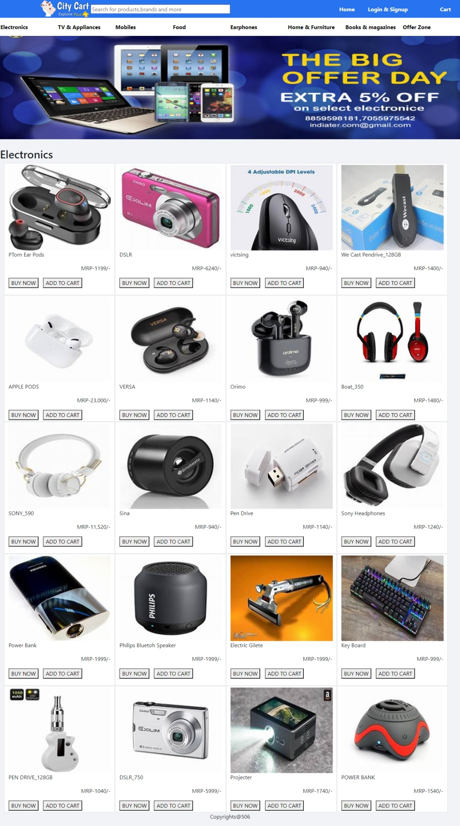
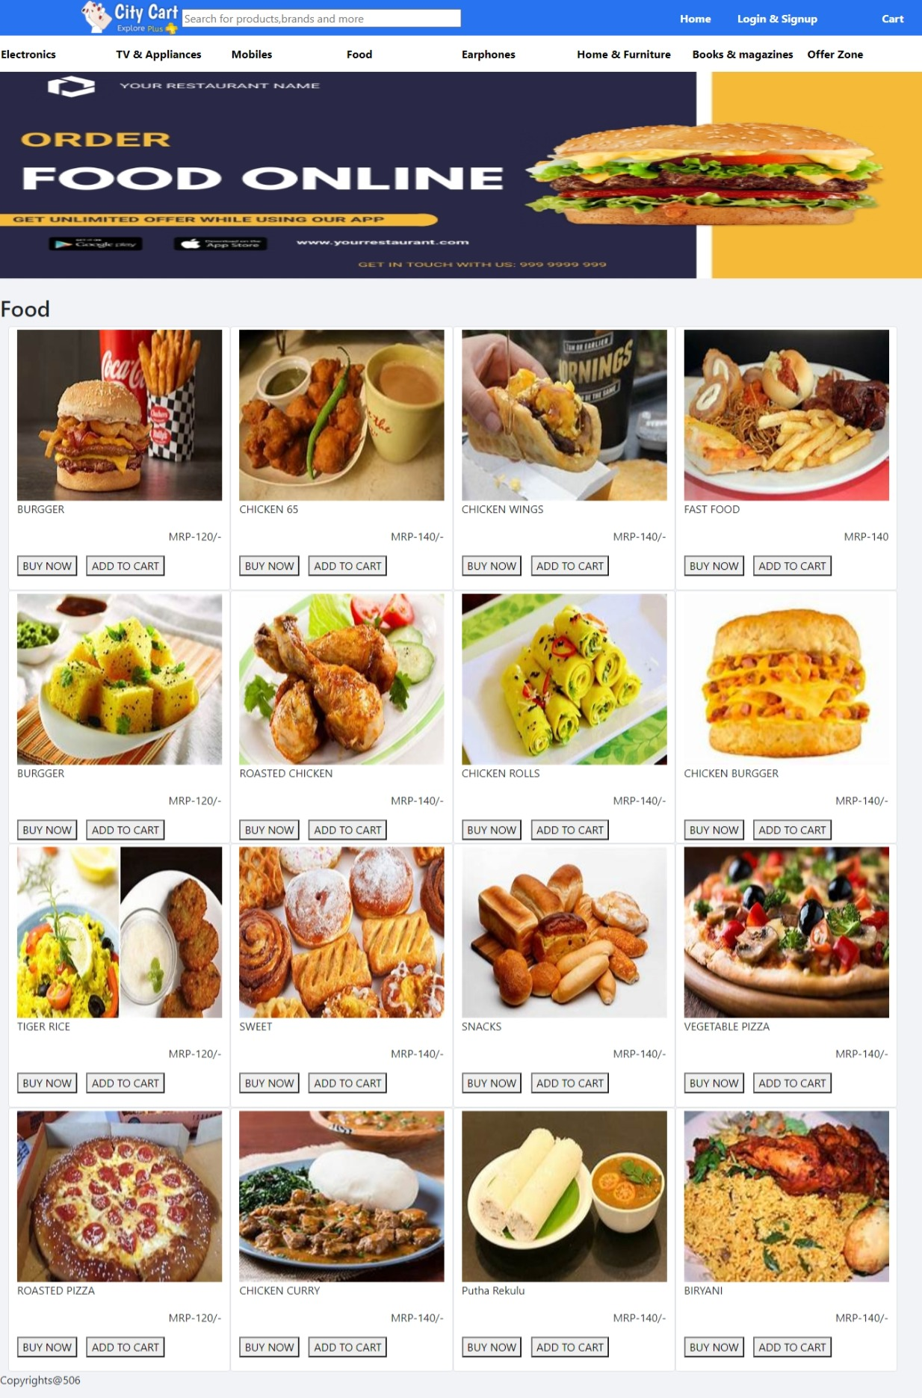

Conclusion:

At the end of this project I learnt basic webdevelopment techniques i.e,Html,Css,Javascript..
I was able to create my own website.
By seeing any website I was able to understand the source code of other websites.

References:

HTML Tutorial (w3schools.com)
CSS Tutorial (w3schools.com)
JavaScript Tutorial (w3schools.com)

